1. INTRODUCTION
1.1. Project Overview
Civil Engineering Insight Studio is an AI-powered structural analysis web application designed to analyze civil engineering structures from uploaded images. The system allows users to upload an image of a structure (bridge, building, dam, road, etc.) and optionally provide a description. Using the Google Generative AI API and the Gemini model (gemini-flash-latest), the application analyzes the structure and provides, safety and design features.
The application is developed using Streamlit for the frontend interface and integrates AI-based image + text analysis for intelligent structural interpretation.
This project demonstrates the practical use of multimodal generative AI in civil engineering education and structural analysis.

1.2. Objectives
The main objectives of the Civil Engineering Insight Studio project are:
- To develop an AI-powered web application for structural image analysis
- To enable users to upload civil structure images for automated explanation
- To integrate a multimodal AI model for image and text-based analysis
- To provide fast, structured, and professional civil engineering insights
- To create an intuitive and modern UI using Streamlit
- To support engineering students and professionals with instant structural understanding

2. Ideation Phase
2.1. Problem Statement
Therefore, the problem is to develop a centralized, intelligent, and user-friendly platform Civil Engineering Insight Studio that leverages data analytics and modern technologies to streamline project planning, improve accuracy, enhance decision-making, and optimize overall construction project performance.
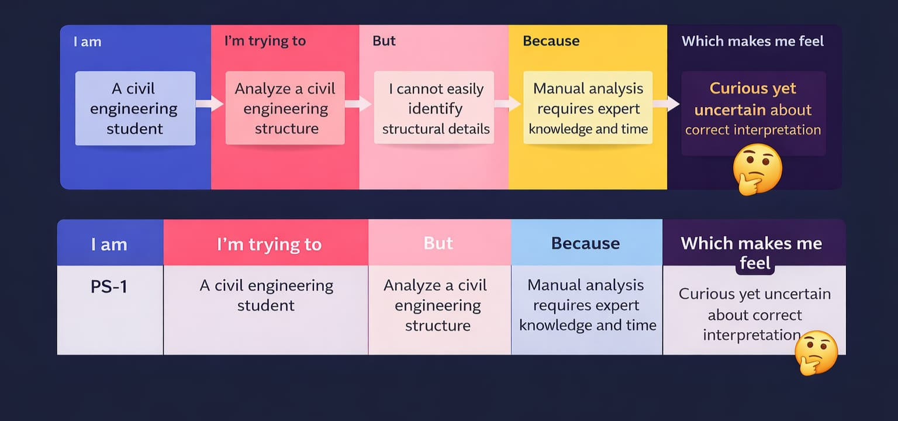
Problem  Statement  (PS) | I am | I’m trying to | But | Because | Which makes me feel
PS-1 | A civil Engineering Student | Analyze a civil engineering structure | I cannot easily identify structural details | Manual analysis requires expert knowledge and time | Curious yet uncertain about correct interpretation
PS-2 | A civil engineering student | Analyze a civil engineering student | Manual analysis requires expert knowledge and time | Manual analysis requires expert | Curious yet uncertain about correct interpretation

2.2. Empathy Map Canvas
Empathy Map Canvas:
An empathy map is a simple, easy-to-digest visual that captures knowledge aboutuser’s behaviours and attitudes. It is a useful tool to helps teams better understand their users.
Creating an effective solution requires understanding the true problem and the person who is experiencing it. The exercise of creating the map helps participants consider things from the user’s perspective along with his or her goals and challenges.

Example:
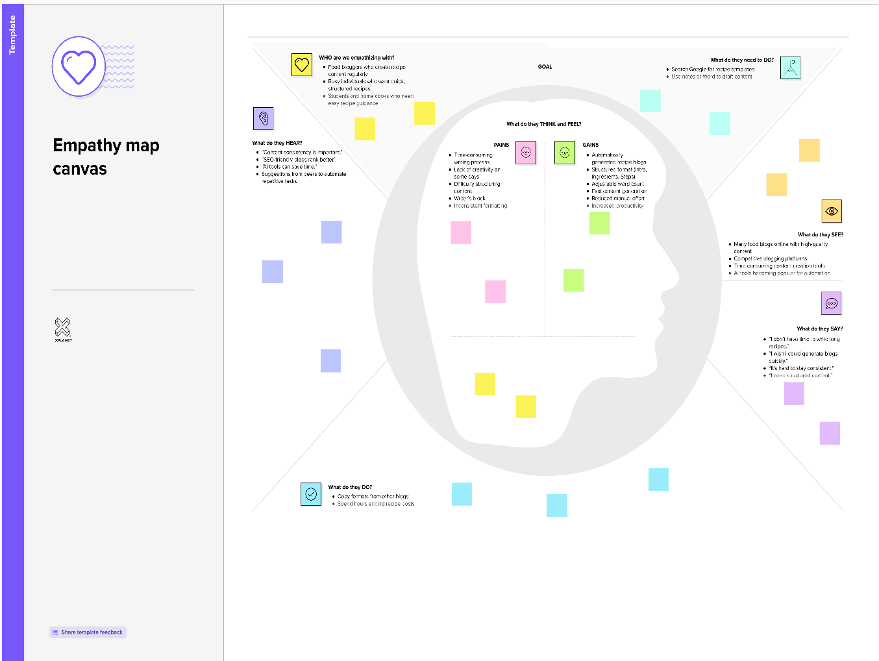

2.3 Brainstorming
Brainstorm & Idea Prioritization:
Brainstorming provides a free and open environment that encourages everyone within a team to participate in the creative thinking process that leads to problem solving. Prioritizing volume over value, out-of-the-box ideas are welcome and built upon, and all participants are encouraged to collaborate, helping each other develop a rich amount of creative solutions.
Use this template in your own brainstorming sessions so your team can unleash their imagination and start shaping concepts even if you're not sitting in the same room.
Step-1: Team Gathering, Collaboration and Select the Problem Statement
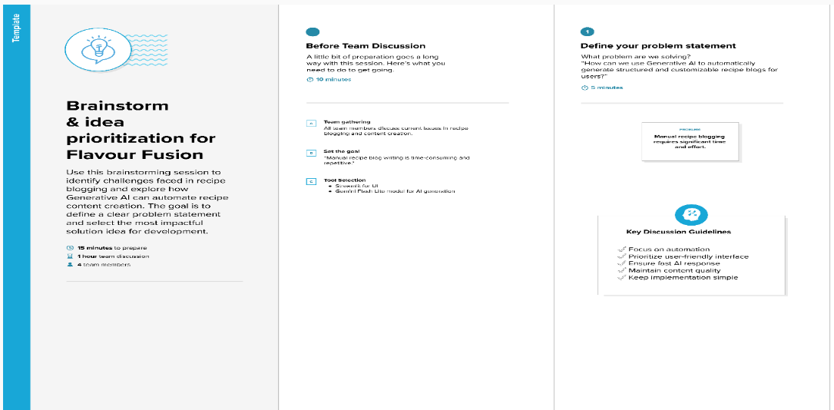

Step-2: Brainstorm, IdeaListing and Grouping
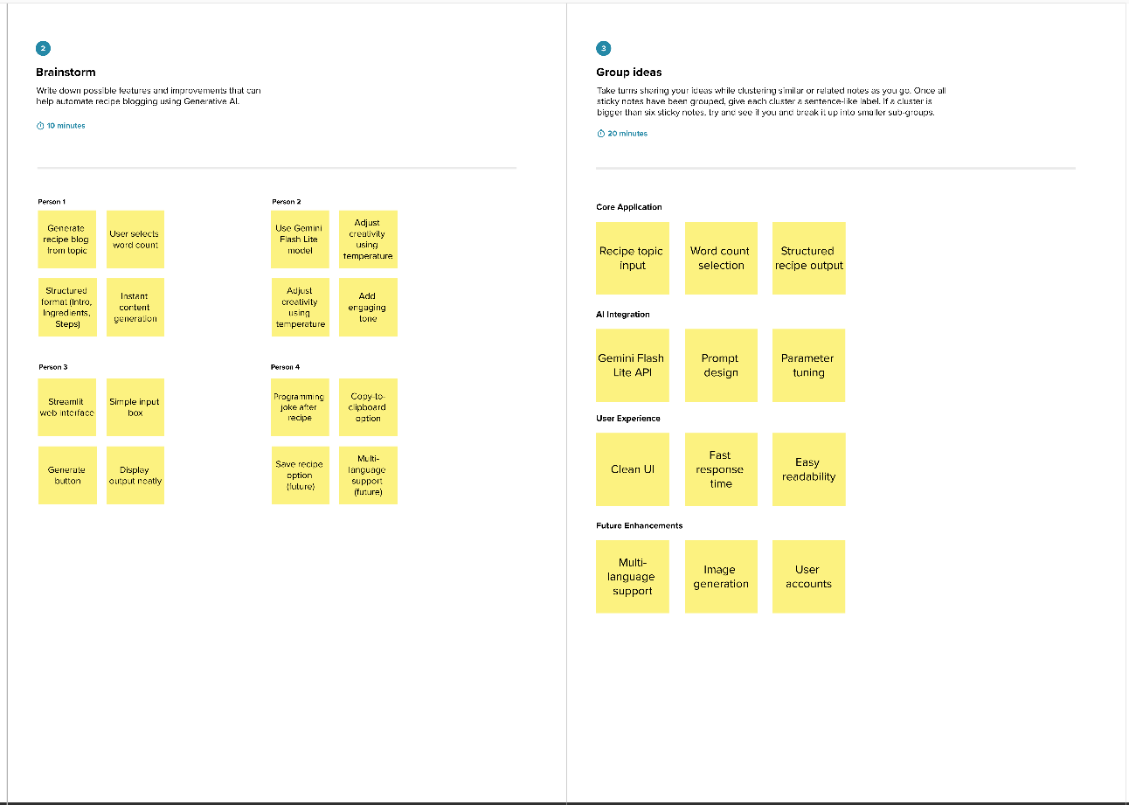

Step-3: Idea Prioritization
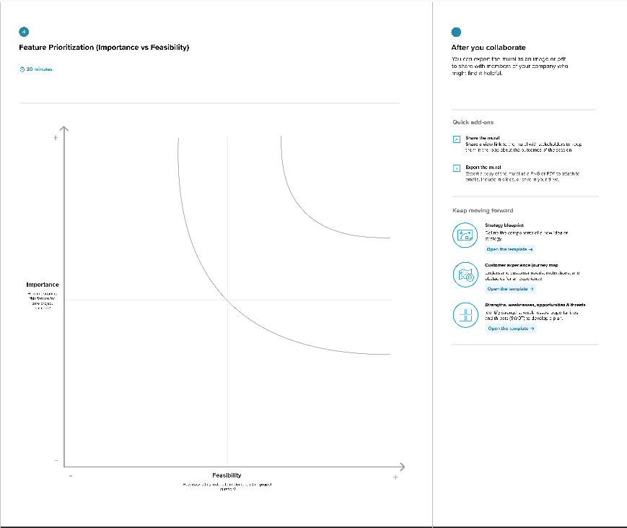

3. Requirement Analysis
3.1. Solution Requirement
Functional Requirements:
Following are the functional requirements of the proposed solution.
FR No. | Functional Requirement (Epic) | Sub Requirement (Story / Sub-Task)
FR-1 | Project Input Module | Enter Project/ topic  Select analysis type
FR-2 | Input Validation | Validate empty input  Validate file format
FR-3 | AI Integration | Connect to Gemini Flash Lite API  Send structured prompt to model process user queries
FR-4 | Analysis & Report Generation | Generate structured engineering report Include Introduction,Methodology,Calculations, results
FR-5 | Output Display | Display generated report in UI  Allow user to copy content
FR-6 | Additional Feature | Generate civil engineering tips / insights (optional feature)

Non-functional Requirements:
Following are the non-functional requirements of the proposed solution.
FR No. | Non-Functional Requirement | Description
NFR-1 | Usability | The application must have a simple and intuitive Streamlit interface that is easy to use.
NFR-2 | Security | API keys must be securely stored and not exposed in the frontend.
NFR-3 | Reliability | The system should generate consistent and structured outputs for valid inputs.
NFR-4 | Performance | Report generation should complete within a few seconds.
NFR-5 | Availability | The application should handle multiple users simultaneously without performance degradation.
NFR-6 | Scalability | The system should handle multiple users without significant performance degradation.

3.2. Data Flow Diagram
Data Flow Diagrams:
A Data Flow Diagram (DFD) is a traditional visual representation of the information flows within a system. A neat and clear DFD can depict the right amount of the system requirement graphically. It shows how data enters and leaves the system, what changes the information, and where data is stored.

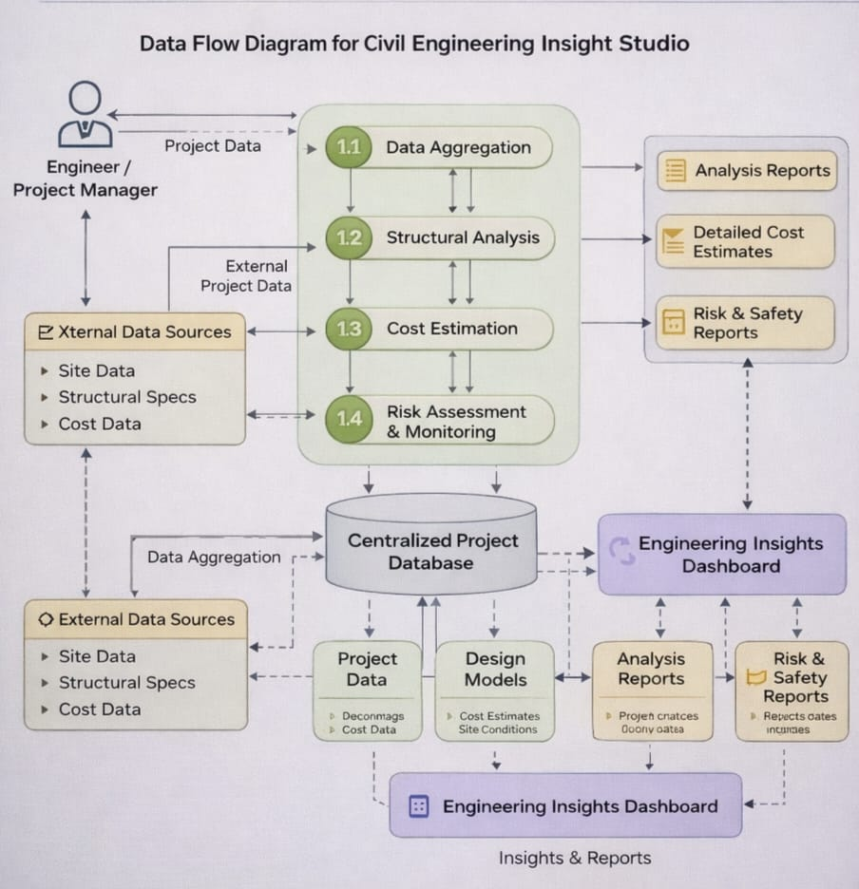
User Stories
Use the below template to list all the user stories for the product.
User Type | Functional Requirement (Epic) | User Story Number | User Story / Task | Acceptance criteria | Priority | Release
Student/Engineer | User Interface Setup | USN-1 | As a user, I can access a Streamlit-based interface to enter a project details. | I can access mydashboard | High | Sprint-1
Administrator | Input Validation | USN-2 | As a user, I want the application to validate my inputs. | I can validate the inputs | High | Sprint-1
System | AI Model Integration | USN-3 | As a user, I want the system to calculate load stress, and material estiamtion using integrated engineering. | I can calculate model | High | Sprint-2
Administrator | Material Estimation & Cost Analysis | USN-4 | As a user, I want to generate a cost estimation reports for construction projects. | I can generate a reports for user interaction | Medium | Sprint-2
Student/Engineer | Output Display | USN-5 | As a user, I want to view graphs and charts representing structural strength, cost and project progress. | I can see the output of graph generated | High | Sprint-3
Deployment Team | Deployment | USN-6 | As a user, I want the application to be deployed and accessible through the internet. | I can deploy in the system | Medium | Sprint-3

3.3. Technology Stack
Technical Architecture:
The Deliverable shall include the architectural diagram as below and the information as per the table1 & table 2
Table-1 : Components & Technologies:
S.No | Component | Description
 | User Interface | Web-based interface where users upload site images, input project details, and request analysis
 | Application Logic-1 | Input validation and preprocessing of civil engineering data
 | Application Logic-2 | Structural analysis, quantity estimation, and report generation logic
 | Application Logic-3 | AI request handling and response processing
 | File Storage | Local storage for uploaded images, reports, and logs
 | External API-1 | Generative AI and recommendations for civil projects
 | Machine Learning Model | Pre-trained generative AI model for text generation
 | Infrastructure (Server / Cloud) | Deployment of application

Table-2: Application Characteristics:
S.No | Characteristics | Description | Technology
 | Open-Source Frameworks | Web framework and development tools used for building civil engineeering analysis platform | Streamlit, Python
 | Security Implementations | Secure storage of API keys and environment variables | Environment Variables (.env), Streamlit Secrets
 | Scalable Architecture | Web-based architecture supporting multiple users  And scalable deployment | Cloud-based deployment (Streamlit Cloud)
 | Availability | Application accessible online after deployment for project analysis and reporting | Streamlit Cloud Hosting
 | Performance | Fast response generation using lightweight AI model and efficient data processing | Gemini Flash Lite (optimized for low latency)

4. PROJECT DESIGN
4.1. Problem Solution Fit
Problem – Solution Fit Template:
The Problem-Solution Fit simply means that you have found a problem with your customer and that the solution you have realized for it actually solves the customer’s problem. It helps entrepreneurs, marketers and corporate innovators identify behavioral patterns and recognize what would work and why
Purpose:
- Solve complex problems in a way that fits the state of your customers.
- Succeed faster and increase your solution adoption by tapping into existing mediums and channels of behavior.
- Sharpen your communication and marketing strategy with the right triggers and messaging.
- Increase touch-points with your company by finding the right problem-behavior fit and building trust by solving frequent annoyances, or urgent or costly problems.
- Understand the existing situation in order to improve it for your target group.
Template:

4.2. Proposed Solution
Proposed Solution Template:
Project team shall fill the following information in the proposed solution template.
S.No. | Parameter | Description
 | Problem Statement (Problem to be solved) | Many civil engineering students, site engineers, and project managers face difficulties in performing quick structural analysis, cost estimation, and technical documentation. Manual calculations and report preparation are time-consuming, prone to errors, and require advanced expertise. There is a need for an automated system that provides accurate analysis, structured reports, and intelligent insights efficiently.
 | Idea / Solution description | Civil Engineering Insight Studio is an AI-powered web application that assists users in structural analysis, material estimation, and project documentation. Users enter project details such as dimensions, material type, and site data, and the system processes the information using predefined logic and a generative AI model to produce structured technical reports and recommendations.
 | Novelty / Uniqueness | Unlike traditional engineering tools that focus only on calculations, this platform integrates Generative AI to provide explanations, design suggestions, and detailed report generation. It combines engineering computation with intelligent insights in a single user-friendly interface.
 | Social Impact / Customer Satisfaction | The solution supports students, engineers, and construction professionals by saving time and improving productivity. It reduces manual errors, enhances understanding through AI-generated explanations, and provides accessible engineering assistance even for beginners.
 | Business Model (Revenue Model) | The application can follow a freemium model where basic structural analysis is free, and advanced features such as detailed AI reports, downloadable documentation, and premium project templates are available through subscription. Revenue can also be generated through institutional licenses and enterprise solutions.
 | Scalability of the Solution | The application is cloud-deployable and designed with scalable architecture. It can handle multiple users simultaneously and can be expanded to include additional modules such as 3D visualization, BIM integration.

4.3 Solution Architecture
Solution Architecture:
The solution architecture of Flavour Fusion consists of a Streamlit-based web application that collects user inputs and validates them. The application constructs a structured prompt and sends it to the Gemini Flash Lite generative AI model through an API call. The AI model generates a structured recipe blog, which is then formatted and displayed to the user. The system can be deployed locally or on a cloud platform such as Streamlit Cloud.

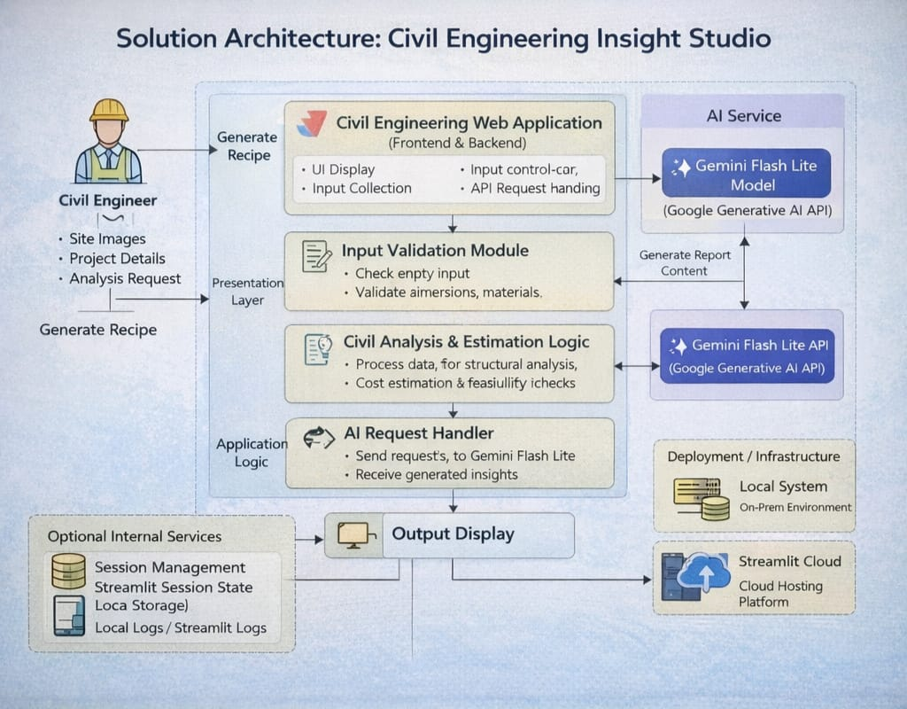

5. PROJECT PLANNING & SCHEDULING
5.1. Project Planning
Product Backlog, Sprint Schedule, and Estimation (4 Marks)
Use the below template to create product backlog and sprint schedule
Sprint | Functional Requirement (Epic) | User Story Number | User Story / Task | Story Points | Priority | Team Members
Sprint-1 | User Interface Setup | USN-1 | As a user, I can access a Streamlit-based interface to enter a recipe topic and word count. | 2 | High | All Team Members
Sprint-1 | Input Validation | USN-2 | As a user, I want the application to validate my inputs before generating the recipe. | 1 | High | All Team Members
Sprint-2 | AI Model Integration | USN-3 | As a user, I want the system to generate a recipe blog using the Gemini Flash Lite model. | 3 | High | All Team Members
Sprint-2 | Joke Generation | USN-4 | As a user, I want to see a programming joke while the recipe is being generated. | 1 | Medium | All Team Members
Sprint-3 | Output Display | USN-5 | As a user, I want to view the generated recipe blog clearly on the screen. | 2 | High | All Team Members
Sprint-3 | Deployment | USN-6 | As a user, I want the application to be deployed and accessible through the internet. | 2 | Medium | All Team Members

Project Tracker, Velocity & Burndown Chart: (4 Marks)
Sprint | Total Story Points | Duration | Sprint Start Date | Sprint End Date (Planned) | Story Points Completed (as on Planned End Date) | Sprint Release Date (Actual)
Sprint 1 | 20 | 4 Days | 28 January 2026 | 31 January 2026 | 20 | 31 January 2026
Sprint 1 | 20 | 4 Days | 28 January 2026 | 31 January 2026 | 20 | 31 January 2026
Sprint 2 | 20 | 8 Days | 02 February 2026 | 09 February 2026 | 20 | 09 February 2026
Sprint 2 | 20 | 8 Days | 02 February 2026 | 09 February 2026 | 20 | 09 February 2026
Sprint 3 | 20 | 7 Days | 12 February 2026 | 18 February 2026 | 20 | 18 February 2026
Sprint 3 | 20 | 7 Days | 12 February 2026 | 18 February 2026 | 20 | 18 February 2026

6. FUNCTIONAL AND PERFORMANCE TESTING
6.1 Performance Testing

Test Scenarios & Results
Test Case ID | Scenario (What to test) | Test Steps (How to test) | Expected Result | Actual Result | Pass/Fail
PT-01 | Image Upload Response Time | Upload a valid JPG/PNG image and click “Describe Structure” | Image loads within 2–3 seconds | Within Limit | Pass
PT-02 | AI Response Time Test | Upload image and trigger analysis | Structural analysis generated within 3–6 seconds | Within Limit | Pass
PT-03 | Large Image Handling | Upload high-resolution image (>5MB) | System processes image without crashing | Stable | Pass
PT-04 | Multiple Request Handling | Perform analysis multiple times consecutively | Application handles requests without lag or crash | Stable | Pass
PT-05 | API Retry Mechanism | Simulate temporary API failure (503 error) | System retries automatically and recovers | Working as Expected | Pass
PT-06 | Memory Usage Test | Monitor RAM usage during repeated analysis | Memory usage remains within acceptable range (<70%) | Within Limit | Pass
PT-07 | UI Rendering Performance | Load the web app in browser | UI loads completely within 2 seconds | Within Limit | Pass
PT-08 | Concurrent User Simulation | Simulate 3–5 users accessing app simultaneously | Application remains responsive | Stable | Pass
PT-09 | Internet Dependency Check | Disconnect internet and trigger analysis | Error message displayed gracefully | As Expected | Pass
PT-10 | Deployment Performance Test | Access deployed app via public link | Application loads and functions correctly | Working | Pass

7. RESULTS
7.1. Output Screenshots
The complete execution of the Civil Engineering Insight Studio application is shown in the images step by step as shown below.
Step 1: Run the app.py code by typing "streamlit run app.py" in the terminal.
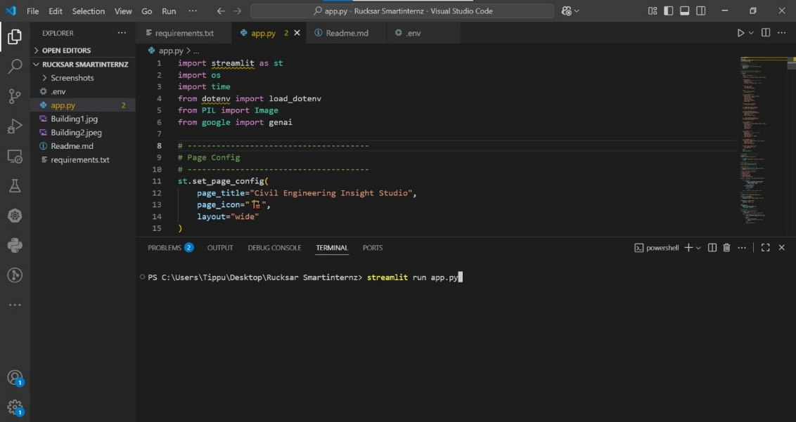
Step 2: you will get a link in terminal as https://localhost:8501 to access the output page and to do the other process.
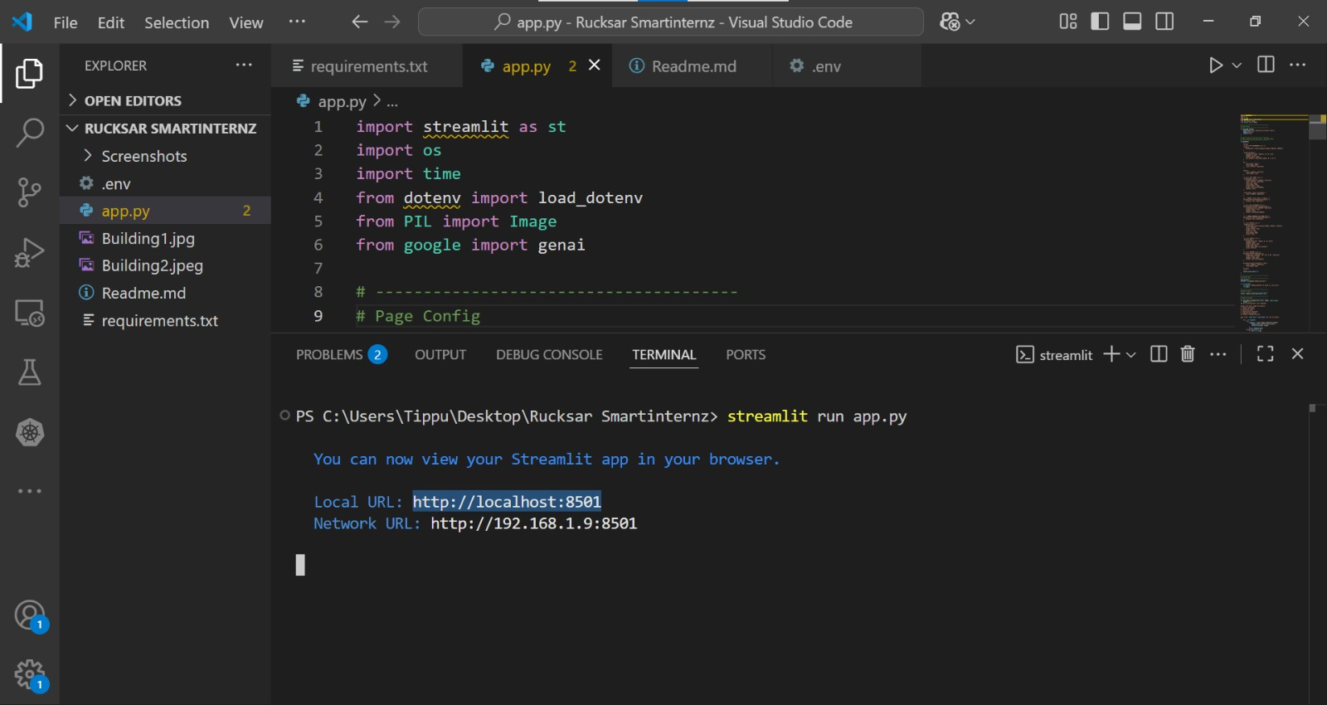
Step 3: By clicking on the optional description search bar and the user can enter the required description.
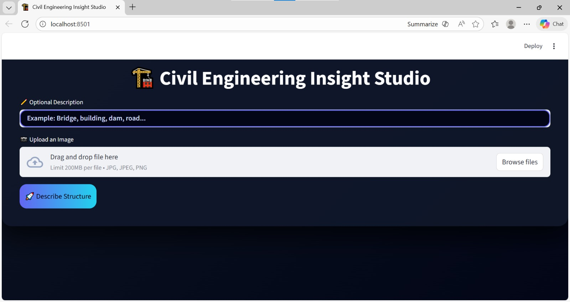
Step 4:Click on Browse files option to choose the images.
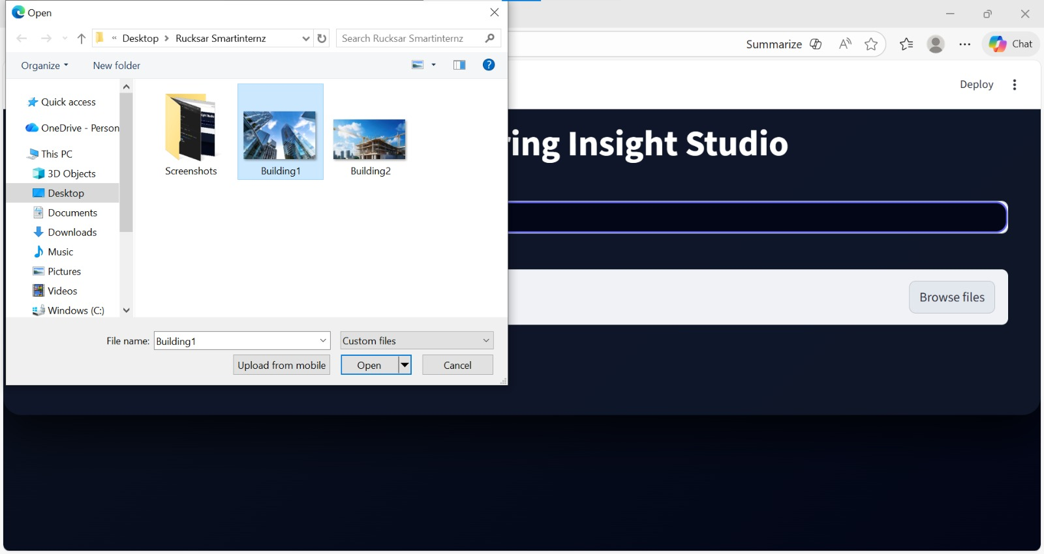

Step 5: The image gets uploaded and then the user clicks on the describe structure option.
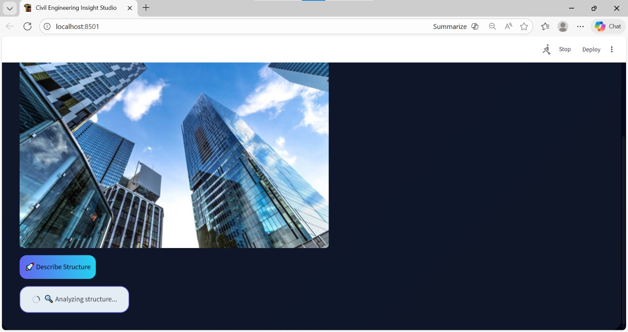
Step 6: It analyzes the image and generate insightful descriptions enabling engineers to make informed decisions and communicate effectively about their projects.
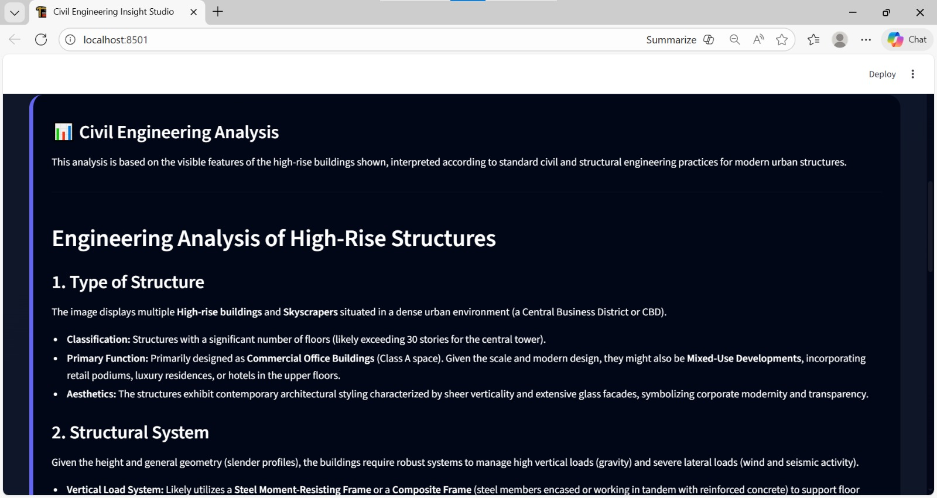

8. ADVANTAGES AND DISADVANTAGES
Advantages
- Instant structural analysis
- Supports image + text input
- Useful for civil engineering students
- No manual structural database required
- Modern and attractive UI
- Fast processing using Gemini Flash
- Enhances learning and productivity
Disadvantages
- Requires internet connection
- Depends on third-party AI API
- AI output may vary slightly
- Cannot replace professional structural design validation

9. CONCLUSION
The Civil Engineering Insight Studio successfully demonstrates the application of multimodal generative AI in civil engineering analysis.By integrating Streamlit with Gemini Flash AI, the project provides,Instant structure identificationProfessional structural explanationEnhanced learning experienceAutomated engineering insight generationThe system bridges the gap between AI technology and civil engineering education, making structural analysis more accessible and efficient.

10. FUTURE SCOPE
The Flavour Fusion project can be enhanced further by adding support for multiple languages to reach a wider audience. Future improvements may include generating recipe images along with text, adding user accounts to save favorite recipes, and providing personalized recipe recommendations. The application can also be extended to support voice-based input and mobile platform deployment, making it more accessible and user-friendly.

11. APPENDIX
11.1. Source Code
The source code for the Civil Engineering Insight Studio: AI-Powered Structural Analysis Application includes the implementation of the Streamlit user interface, integration of the Gemini Flash model using the Google Generative AI API, image analysis logic, structured output generation, and error-handling mechanisms.The application is developed using Python and follows a modular, clean, and readable structure.
11.2. Github& Project Demo Link
Github Repository Link:
https://github.com/ShaikRucksar123/Civil-Engineering-Insight-Studio
Demo Link:
https://drive.google.com/file/d/1mh9k619qjylvpth4XZvxMuO3HmlNp6W8/view?usp=drivesdk

